Sample System Structure and Architecture Design

|  |  |  |
| --- | --- | --- |
| Version | Date | Changes |
|  |  |  |
|  |  |  |
|  |  |  |
|  |  |  |
|  |  |  |

Catalogue

1 Introduction / Background 4

2 Environment 4

3 System Requirement 4

4 Use Cases 4

5 Structure Design 5

6 Process Design 6

6.1 Gross sales process 6

6.1.1 Read product brand 6

6.1.2 Read sell-in 6

6.1.3 Read distributor customer 7

6.1.4 Read sellout 7

6.1.5 Process sell-in 7

6.1.6 Process sell-in stage 34 7

6.1.7 Read manual adjustment 7

6.1.8 Create sellout split ratio 8

6.1.9 Create brand channel 8

6.2 Fee process 8

6.2.1. Read SAP FI 9

6.2.2. Read TPM 9

6.2.3. Split TT 9

6.2.4. Split Rebate 9

6.2.5. Split SAP_SD 9

6.2.6. Split Reversal Rebate 10

6.2.7. Split Reversal TT 10

6.2.8. Split System Error 10

6.2.9. Split TP 11

6.2.10. Merge all 11

6.3 Cost process 11

6.3.1 Read production cost 12

6.3.2 Process production cost 12

6.4 A&P process 12

6.4.1 Read A&P 12

6.4.2 Process A&P 12

6.5 Report generating process 13

7 Report file template 13

# Introduction / Background

The current report is created manually. It takes a lot of time and effort.

The report is a quarterly report. It shows data by channel. The granularity of this report is not detailed enough.

# Environment

Jupyter Lab with Python on a single machine.

# System Requirement

An automatic or semi-automatic process is going to be developed. This process can be used to generate P&L report on monthly bases. Each monthly report should show P&L content in brand channel level (by brand by channel).

# Use Cases

The main use case is to generate monthly P&L report by brand by channel. This use case can be split into below uses.

1. Create split ratio

Create sell-out split ratio, sell-in split ratio, sell-in split ratio with stage 3 and stage 4 products only.

1. Create gross sales by brand by channel

Read created split ratio. Create sell in volume and gross sales value by brand by channel.

1. Create fee by brand by channel

Read created split ratio. Create fee data by brand by channel. Fee includes rebate, sales, discount, trading term, and trade promotion.

1. Create cost by brand by channel

Read created split ratio. Create cost data by brand by channel. Cost includes production cost and logistic cost.

1. Create A&P by brand by channel

Read created split ratio. Create A&P (advertisement and promotion) data by brand by channel. A&P includes BU marketing cost, total other marketing costs, and HCN.

1. Create final report

Combine generated by brand by channel data and create final P&L report.

# Structure Design

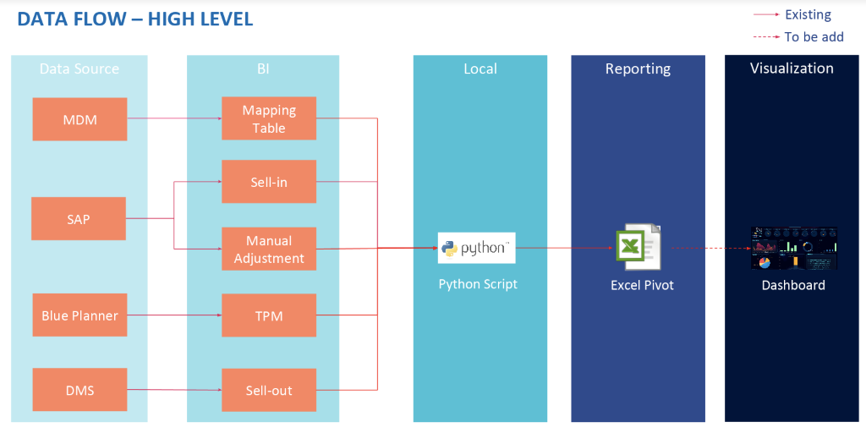

# Process Design

The system can be divided into 5 major processes. Each process will generate one section of the report.

## Gross sales process

This process will be triggered monthly after sell-out data is ready. It will read sell-out data from past 3 months and generate a distributor-grade split ratio.

### Read product brand

This process reads products data from MDM system.

This process creates a mapping from product code to brand stage and brand information.

### Read sell-in

This process reads sell-in data from BI system. It filters records using document type code.

Records with below codes will be kept to compute sell-in value.

* ZRE2
* ZCL1
* ZSO
* ZCR
* ZCR1
* ZDR
* ZDR1

Records with below codes will be kept to compute sell-in volume.

* ZRE2
* ZCL1
* ZSO

This process creates monthly sell-in value and volume information.

### Read distributor customer

This process reads distributor and customer information from MDM system. Channel mapping from business is also needed.

This process creates below mapping information.

* Monthly customer to grade and channel mapping.
* Monthly distributor to grade and channel mapping by using the customer attached to distributor.
* Distributor to grade and channel mapping by using SP group of this distributor.

### Read sellout

This process reads non-split sell-out data from DMS system.

This process creates monthly sell-out value information.

### Process sell-in

This process reads previously created monthly sell-in information. It enriches sell-in with brand stage and brand information.

This process also creates three monthly sell-in split ratios.

A split ratio from total sell-in of a brand stage to individual distributors under this brand stage.

A split ratio from total sell-in to each brand stage.

A split ratio from total sell-in of a distributor to all brand stages under this distributor.

### Process sell-in stage 34

This process reads previously created monthly sell-in information. It creates monthly sell-in split ratio for stage 3 and stage 4 products only. It shows the split ratio from total sell-in of a distributor to all brand stages under this distributor.

### Read manual adjustment

This process reads manual adjustment information.

This process creates monthly sales value manual adjustment and monthly sales volume manual adjustment.

### Create sellout split ratio

This process reads previously generated results and calculate the monthly sell-out split ratio.

This is a split ratio from total sell-out of a distributor to all grades and channels mapped to this distributor.

If a distributor does not have sell-out for given month below logics will be applied. First the process will check if distributor is mapped to only one grade and channel. If so, the split ratio will be set to one to one. If not split ratio from past months will be used.

### Create brand channel

This process reads previously generated results and calculate monthly gross sales by brand by channel.

Sell-in, sales value manual adjustment, and sales volume manual adjustment are loaded. Sell-out split ratio is used to split these data to brand and channel level. If a distributor cannot be mapped by using sell-out split ratio, SP group of this distributor will be used to determine the channel.

This process also creates monthly sell-in by document type by brand by channel.

## Fee process

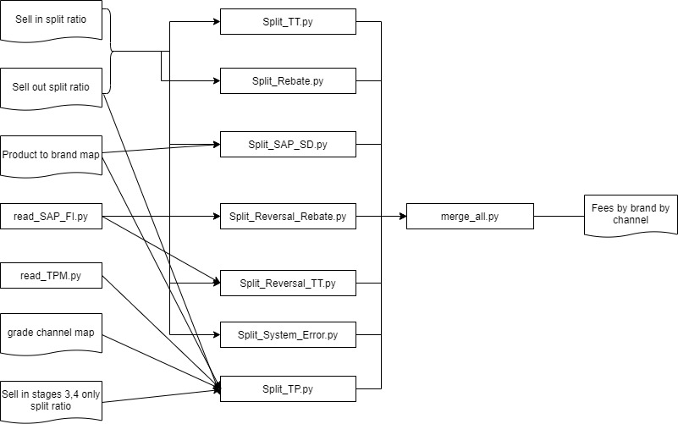

### Read SAP FI

This process reads SAP FI (including Rebate and TT reversal) data from SAP FI system.

This process creates monthly SAP FI (including Rebate and TT reversal) value information.

### Read TPM

This process reads TP (Trade promotion) data from blue planner system.

This process creates monthly TP value information.

### Split TT

This process reads previously created three monthly distributor-sell-in split ratios.

This process reads previously created monthly distributor-sell-out ratios.

This process reads TT value information.

This process splits TT by brand using three monthly distributor-sell-in split ratios and by channel using monthly distributor-sell-out ratios.

For some distributors without sell-in, this process is using distributor-sellout split ratios to split it by brand.

### Split Rebate

This process reads previously created three monthly distributor-sell-in split ratios.

This process reads previously created monthly distributor-sell-out ratios.

This process reads Rebate value information.

This process splits Rebate by brand using three monthly distributor-sell-in split ratios and by channel using monthly distributor-sell-out ratios.

For some distributors without sell-in, this process is using distributor-sellout split ratios to split it by brand.

### Split SAP_SD

This process reads previously created monthly distributor-sell-out ratios.

This process reads TT & Discount on invoice value information.

This process splits TT & Discount on invoice by channel using monthly distributor-sell-out ratios.

### Split Reversal Rebate

This process reads previously created three monthly sell-in split ratios.

This process reads previously created monthly sell-out ratios.

This process reads Reversal Rebate value information.

This process splits Reversal Rebate from ELN to brand stage using three monthly sell-in split ratios and from all channel to grade/channel using monthly sell-out ratios.

### Split Reversal TT

This process reads previously created three monthly sell-in split ratios.

This process reads previously created monthly sell-out ratios.

This process reads Reversal TT value information.

This process splits Reversal TT from ELN to brand stage using three monthly sell-in split ratios and from all channel to grade/channel using monthly sell-out ratios.

### Split System Error

This process reads previously created three monthly sell-in split ratios.

This process reads previously created three monthly sell-in split ratios with stage 3 and stage 4 products only.

This process reads previously created monthly sell-out ratios.

This process reads TT & Discount System Error value information.

This process reads Rebate System Error value information.

This process reads TP System Error value information.

This process splits TT & Discount System Error from ELN to brand stage using three monthly sell-in split ratios and from all channel to grade/channel using monthly sell-out ratios.

This process splits Rebate System Error from ELN to brand stage using three monthly sell-in split ratios and from all channel to grade/channel using monthly sell-out ratios.

This process splits TP System Error from ELN to brand stage using three monthly sell-in split ratios with stage 3 and stage 4 products only and from all channel to grade/channel using monthly sell-out ratios.

### Split TP

This process reads previously created three monthly sell-in split ratios with stage 3 and stage 4 products only.

This process reads previously created monthly sell-out ratios.

This process reads previously created monthly TP value information.

This process splits TP from (Product : product, Channel : grade) to (Product : SKU, Channel : grade)

This process splits TP from (Product : brand, Channel : grade) to (Product : SKU, Channel : grade) using three monthly sell-in split ratios.

This process splits TP from (Product : all-brand, Channel : grade) to (Product : SKU, Channel : grade) using three monthly sell-in split ratios.

This process splits TP(Product : all-brand, Channel : all channel) to (Product : SKU, Channel : grade) using three monthly sell-in split ratios and using monthly sell-out ratios.

For some distributors without sell-in, this process is using sellout split ratios to split it by brand.

### Merge all

This process reads previously created TP monthly by brand by grade/channel split results.

This process reads previously created TT & discount monthly by brand by grade/channel split results.

This process reads previously created Rebate monthly by brand by grade/channel split results.

This process reads previously created TP system error monthly by brand by grade/channel split results.

This process reads previously created TT & discount system error monthly by brand by grade/channel split results.

This process reads previously created Rebate system error monthly by brand by grade/channel split results.

This process merge all previously created results to get the output.

## Cost process

### Read production cost

This process reads production cost data from Themis BI (AR1) system. A configuration file was provided to extract only selected data from AR1. This process also reads production cost data from L500. These data are not recorded in system and manually provided.

This process creates monthly production cost data.

### Process production cost

This process reads previously generated production cost data. It regroups data using provided P&L report format. The process also split production cost using sell-in and sell-out split ratio. Sell-in split ratio is used to split production cost data into brand level. Sell-out split ratio is used to spit brand level production cost to channel level.

This process creates monthly production cost by brand by channel in P&L report format.

## A&P process

### Read A&P

This process reads A&P data from SAP system. A configuration file was provided to map A&P data with team and department information. Another configuration file was provided to map A&P data into A&P items using team and department information.

This process creates monthly A&P data.

### Process A&P

This process reads previously generated A&P data. It regroups data using provided P&L report format. The process also split production cost using gross sales.

This process creates monthly A&P by brand by channel in P&L report format.

## Report generating process

This process will be triggered monthly. It will read sell-in data, split ratio, and other input data to generate report. This process contains below sub-processes.

This process reads previously generated results. Combine all results together and calculate report items like CANN, CO.

This process creates monthly P&L by brand by channel report.

# Report file template

